

NNMC Business Administration Department Student Survey

29 responses

[Publish analytics](https://docs.google.com/forms/d/149ytRHrL0wfD3W7qt8ZusbmXRmduXA3ru65iJfKNkUI/edit#start%3Dpublishanalytics)



# Please indicate your gender identity?

28 responses

## Copy

78.6%

Male Female

Non-binary/Genderqueer Transgender

Prefer not to answer

21.4%

# What is your age?

28 responses

## Copy

17.9%

10.7%

25%

10.7%

<20

20-25

26-30

31-35

36-40

>40

Prefer not to answer



25%



**What state do you live in?**

29 responses

Copy

20

15

10

5

11 ((33..44%%))

11 ((33..44%%))

0

New Mexico

NM

New mexico

Nm

Texas

3 (10.3%)

8 (27.6%)

16 (55.2%)



**What county do you live in?**

28 responses

Copy

10.0

7.5

99 ((3322..11%%))

5.0

2.5

33 ((1100.77%%))

22 ((77..11%%))

22 ((77..11%%))

11 ((33.66%%11))((33.66%%11))((33.66%%11 ))((33.66%%11))((33.66%%11))((33.66%%))

11 ((33.66%%11 ))((33.66%%))

11 ((33.66%%11))((33.66%%11))((33.66%%))

11 ((33.66%%

0.0

Bernalillo

RA

Rio arriba

US

Espanola Rio Arriba Santa Fe United States



**What is your current zip code?**

28 responses

Copy

8

6

4

2 11

0

79938

87064

87144

87506

87510

87522

87547

87582



|  |  |  |  |  |  |  |  |  |  |  |  |  |  |  |  |  |  |  |  |  |  |  |  |  |  |  |  |  |  |  |  |  |  |  |  |  |  |  |  |  |  |  |  |  |  |
| --- | --- | --- | --- | --- | --- | --- | --- | --- | --- | --- | --- | --- | --- | --- | --- | --- | --- | --- | --- | --- | --- | --- | --- | --- | --- | --- | --- | --- | --- | --- | --- | --- | --- | --- | --- | --- | --- | --- | --- | --- | --- | --- | --- | --- | --- |
| 88 (( | | | | | | | | | | | | | | | | | | | | | | | | | | | | | | | | | |  |  | %%)) | | | | | | | | | |
| 2288..66 | |
|  | | | | | | | | | | | | | | | | | | | | | | | | | | | | | | | | | |  | | | | | | | | | |
|  | | | | | | | | | | | | | | | | | | | | | | | | | | | | | | | | | |  | | | | | | | | | |
|  | | | | | | | | | | | | | | | | | | | | | | | | | | | | | | | | | |  | | | | | | | | | |
| 33 ((1100..77%%)) | | | | | | | | | | | | | | | | | | | | | | | | | | | | | | | | | |  | | | | | | | | | |
|  | | | | | | | | | | | | | | | | | | | | | | | | | | | | | | | |  | |
| 22 ((77..11%%)) 22 ((77..11%%)) | | | | | | | | | | | | | | | | | | | | | | | | | | | | | | |  | |  | 22 ((77..11%%22))((77..11%% | | | | | | | | | |
|  | | | | | | | | | | | | | |  | | | | | | | | |  | | | | | | | |  | | | | |  | | |  | |
| ((33.66%%11))((33.66%%11)) ((33.66%%11))((33.66%%)) | | | | | | | | | | | | |  | | 11 ((33.66%%11))((33.66%%)) | | | | | | |  | | 11 ((33.66%%11))((33.66%%)) | | | | | | |  | 11 ((33.66%%)) | | | |  | |  |  | |  |
|  | |  | | |  | | |  | | |  | |  | |  | | |  | |  | |  | | |  | |  | |  | |
|  |  | |  |  | |  |  | |  |  | |  |  |  | |  |  | |  |  |  | |  |  | |  |  |  |  | |  |  |  |

# Did you complete high school in Northern New Mexico?

29 responses

## Copy

27.6%

Yes No

72.4%

# Are your married or cohabitating?

29 responses

## Copy

69%

Yes No

Prefer not to answer

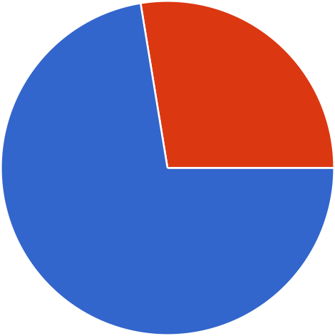

27.6%



**How many dependents do you have?**

29 responses

Copy

10.3%

17.2%

17.2%

0

1

2

3

>3

Prefer not to answer

48.3%

**CURRENT ACADEMIC STATUS**



# What degree are you currently registered in?

29 responses

## Copy

37.9%

Bachelor's Degree Associates Degree Certificate

Other / none

62.1%

# What is your current major?

29 responses

## Copy

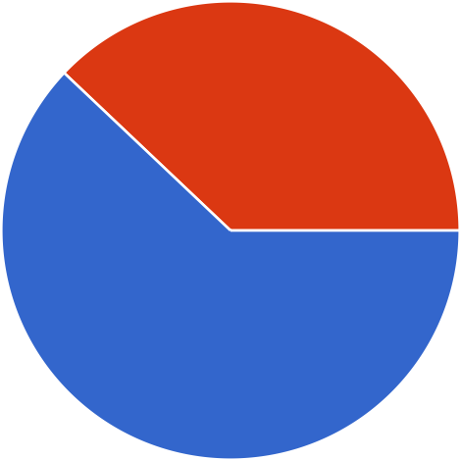

34.5%

31%

20.7%

10.3%

BBA/ Management BBA / Accounting

BBA / Project Management AA / Business Administration AAS / Office Administration AAS / Barbering

AAS/ Cosmetology Certificate Program

# Do you plan to complete your Bachelor's Degree at NNMC?

29 responses

## Copy

20.7%

Yes Probably Probably Not No

75.9%

# Why did you choose NNMC?

29 responses

## Copy

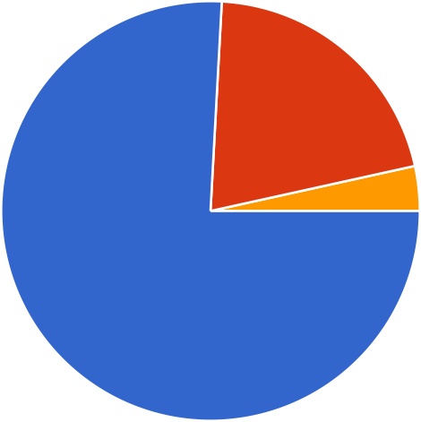

41.4%

34.5%

10.3%

Reputation

NNMC offers the degree program I want

Received NNMC scholarship or financial aid

Location: close to home

Size of NNMC (i.e. Classes, Campus)

Only school that admitted me Online Courses



Copy

**Do you plan to move away from the area after you finish your degree?**

29 responses

Yes

No

89.7%

10.3%



Copy

**What type of financial aid are you receiving? (Check all that apply)**

29 responses

Scholarship/ Grant

2288 ((9966..66%%))

Work Study

11 ((33.44%%))

Loan

22 ((66.99%%))

None

00 ((00%%))

0

10

20

30



**If you plan to transfer or leave prior to completing your degree, where do you plan to go? (write N/A if not applicable)**

26 responses

Copy

30

20

10

0

N/A

Na

No

UNM



|  |  |  |
| --- | --- | --- |
|  | | |
|  | 23 (88.5%) |  |
|  |  |
|  |  |
|  |  |
|  | 11 ((33.88%%)) 11 ((33.88%%)) 11 ((33.88%%)) |

**If you plan to transfer or leave NNMC, what are the reasons? (write N/A if not applicable)**

26 responses

N/A

Na

If I leave it would be for a job opportunity

N/A

Rude teachers.

New opportunities



Copy

**Approximately how many hours per week will you be employed off**

**campus this semester?**

29 responses

69%

None 1-20

21-39

40 or more

13.8%

13.8%



**If you plan to change your major, what do you hope to change it to:**

28 responses

Copy

67.9%

25%

BBA/ Management BBA / Accounting

BBA / Project Management AA / Business Administration AAS / Office Administration AAS / Barbering

AAS/ Cosmetology Certificate Program

Not applicable



**What is your expected graduation date?**

26 responses

Copy

3

33 ((1111..55%%))

22 ((77.77%%))

22 ((77.77%%))

2

11 ((33.8811%%((33)).8811%%((33)).1188%%((33)).8811%%((33)).1188%%((33)).8811%%((33)).8811%%((33)).1188%%((33)).8811%%((33)).1188%%((33))..8811%%((33)).1188%%((33))..88%%

11 ((33.8811%%((33)).1188%%((33))..88%% ((33.1188%%((33))..8811%%((33)).88

1

0

05-17-2025

2028

December 2025 May 16, 2025

Not sure yet

UNKNOWN

2026 5/17/2025 Fall2026 May 2025 Spring 2026

)) 11

))

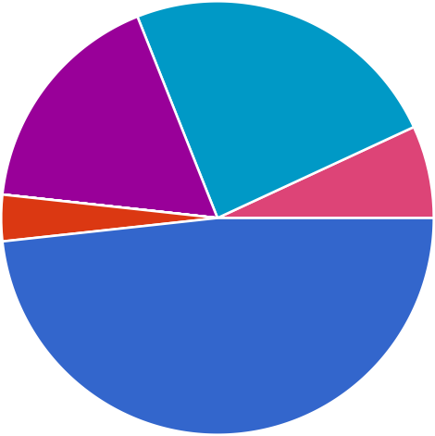

Copy

**What do you hope to accomplish by completing a degree at NNMC?**

29 responses

24.1%

17.2%

48.3%

Employment in Government or LANL

Small Business Employment Corporate Employment Retail / Service employment Self-employment

Promotion / advancement at current job

Other

**FEEDBACK AND IMPROVEMENTS**



Copy

**Would you like to be part of a cohort. A cohort is a group of students**

**who take courses together until completion?**

29 responses

41.4%

Yes No

Maybe

13.8%

44.8%



**What class times are best for you? (check all that apply)**

29 responses

Copy

8:00 am

9:30 am

11:00 am

11 ((33.44%%))

11 ((33.44%%))

33 ((1100.33%%))

2:00 pm

33 ((1100.33%%))

4:30 pm

6:00 pm

44 ((1133.88%%))

77 ((2244..11%%))

web courses - flexible time

2255 ((8866.22%%))

0

10

20

30



Copy

**What is your access to a readily available PC and high-speed internet for**

**your coursework?**

28 responses

35.7%

50%

I have excellent access to a PC and high-speed internet.

I have adequate access to a PC and high-speed internet.

I have limited access to a PC and high-speed internet.

I have poor access to a PC and high-speed internet.

I have no access to a PC and…

Access to PC and poor internet



Copy

**What type of course delivery method would you prefer?**

29 responses

82.8%

Two days per week/ 75-minute class/16 weeks

Two days per week/ 115-minute class/ 8 weeks

One day per week/ 240-minute class/ 5 weeks

Hybrid (half face-to-face / half online)

100% online and asynchronous



Copy

**I feel that I'm academically well prepared for college.**

29 responses

48.3%

Strongly Agree Somewhat Agree Somewhat Disagree Strongly Disagree

Don't Know

44.8%



Copy

**I feel that I'm well prepared for mathematics in college.**

29 responses

Strongly Agree

Somewhat Agree Somewhat Disagree

55.2%

Strongly Disagree

Don't Know

27.6%



Copy

**NNMC has highly qualified Business Administration academic**

**programs.**

29 responses

20.7%

Strongly Agree Somewhat Agree Somewhat Disagree Strongly Disagree

Don't Know

69%



Copy

**The people in the Business Administration department seem friendly**

**and helpful.**

29 responses

Strongly Agree

13.8% Somewhat Agree

Somewhat Disagree

10.3% Strongly Disagree Don't Know

72.4%



Copy

**The Business Administration department is effective at communicating**

**important dates, changes, and opportunities?**

28 responses

10.7%

14.3%

Strongly Agree Somewhat Agree Somewhat Disagree Strongly Disagree

Don't Know

67.9%

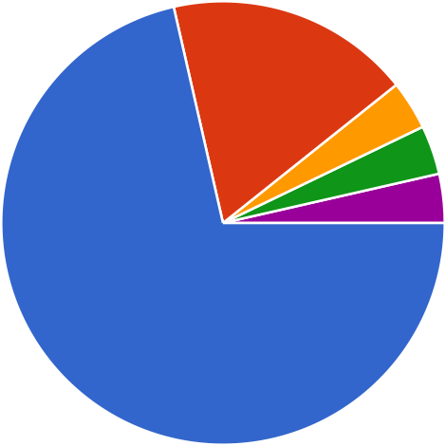

Copy

**The professors/ instructors and Business Administration department**

**are qualified and prepared.**

28 responses

17.9%

Strongly Agree Somewhat Agree Somewhat Disagree Strongly Disagree

Don't Know

71.4%

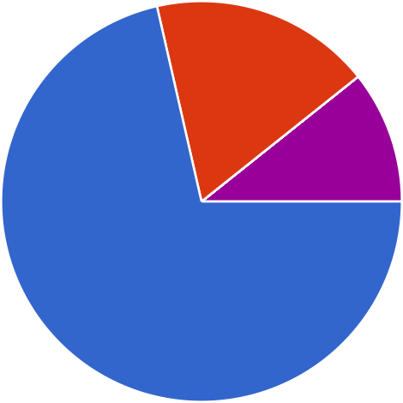

Copy

**The curriculum is relevant for my intended career path.**

28 responses

17.9%

Strongly Agree Somewhat Agree Somewhat Disagree

10.7% Strongly Disagree Don't Know

71.4%



Copy

**It is difficult to earn good grades in the business courses.**

28 responses

28.6%

14.3%

7.1%

Strongly Agree Somewhat Agree Somewhat Disagree Strongly Disagree

Don't Know

14.3%

35.7%

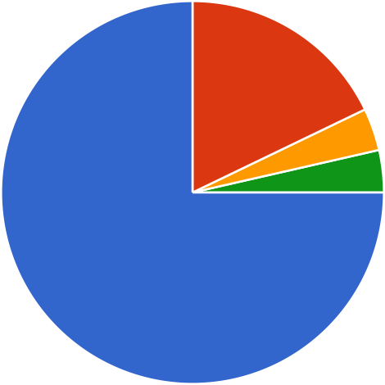

Copy

**How likely are you to recommend the NNMC Business Department to**

**prospective students?**

28 responses

17.9%

Highly likely Somewhat likely Neutral/Unsure Somewhat unlikely

Highly unlikely

75%



Copy

**I will probably change my major at least once.**

28 responses

28.6%

32.1%

Strongly Agree Somewhat Agree Somewhat Disagree Strongly Disagree

Don't Know

7.1%

14.3%

17.9%



Copy

**I worry about financing my college education.**

28 responses

10.7%

14.3%

7.1%

35.7%

Strongly Agree Somewhat Agree Somewhat Disagree Strongly Disagree

Don't Know

32.1%



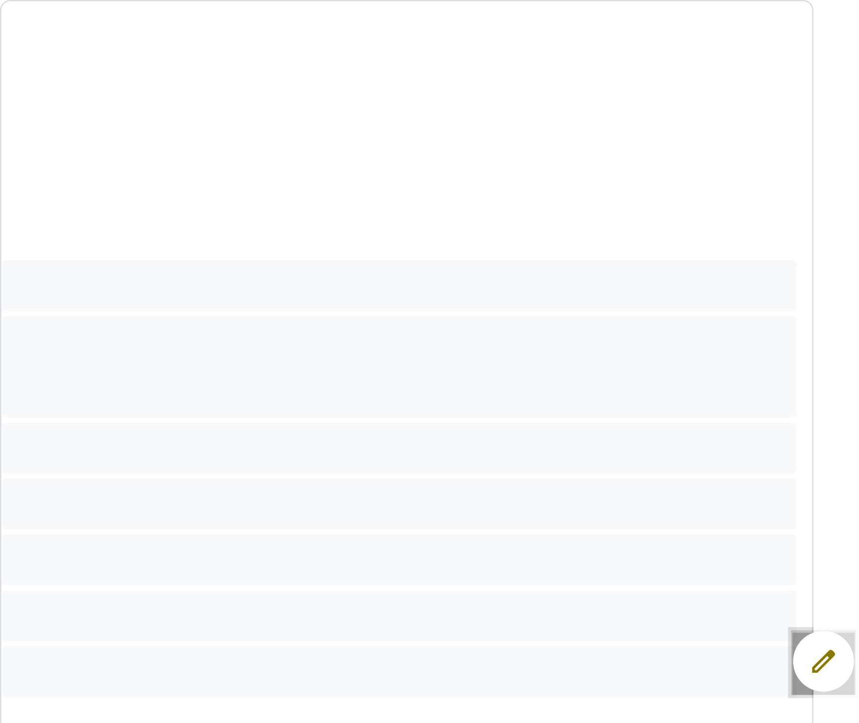

# Please mention the three most important things that the Business Administration Department should do to keep you very satisfied with the college.

**Some examples: Class schedule, wireless internet, room to study, better instructors student association, financial aid, student association, accelerated BA program, etc.**

20 responses

### N/A

Some courses have way too much work being asked to do for it being on online course. The schedule in which certain courses want work to get done vary too much and some don't give enough time.

### ONLINE CLASSES, FINANCIAL AID, ROOMTO STUDY

100% online, Financial aid, available help

Class schedule, financial aid, accelerated BA program None

Class availability, asynchronous, class size

Class size, class offerings, asynchronous



A full week for final. Longer library hours. Better accounting course.

Online Course Delivery, Accelerated BA program, Simplifying the transfer of credits from previous colleges

More online face to face with instructors like an introduction so we know who's who. I'd like a HR certificate but don't know how this is offered. A QB course would be great! Or other business applications courses

### ALL LISTED

Financial aid/scholarships, Class schedule, more communication from Business Administration Department.

I can't think of anything Class Schedule

Timely Responses to students Efficient grading system Manageable work load

Having teachers that teach would be great and not giving 13 assignments due in 5 days. The

work load for SOME classes is way to much for a full time employee.

I honestly don’t know I think the business department is great. Maybe more in person classes.

The most important accessibility that northern has provided is the online/asynchronys courses. This has allowed me to be a mother and work full time.

I think that the class schedules are great and there are many options.

I also thing that financial aid like the opportunity scholarship is a great driver in my being able to afford college.



# Additional Comments



9 responses

### N/A

Im really enjoying this program. -Thank you Great program

None

I feel like I have no idea who anyone is in the Business Administration Department. I changed my major last semester from Nursing to Business and feel like I’ve had 0 conversations or check-ins from staff. It’s my first time at finally accomplishing an associates degree, so some type of feedback and support would be nice.

### N/A

This content is neither created nor endorsed by Google. - [Terms of Service](https://policies.google.com/terms) - [Privacy Policy](https://policies.google.com/privacy) Does this form look suspicious?  [Report](https://docs.google.com/forms/d/149ytRHrL0wfD3W7qt8ZusbmXRmduXA3ru65iJfKNkUI/reportabuse)

[](https://www.google.com/forms/about/?utm_source=product&utm_medium=forms_logo&utm_campaign=forms) [Forms](https://www.google.com/forms/about/?utm_source=product&utm_medium=forms_logo&utm_campaign=forms)

